QUESTION 1
1. Geospatial Data Visualization
Dataset
City | Latitude | Longitude | Population (Millions)
Chennai | 13.08 | 80.27 | 11
Bangalore | 12.97 | 77.59 | 13
Hyderabad | 17.38 | 78.48 | 10
Mumbai | 19.07 | 72.87 | 20
Delhi | 28.61 | 77.21 | 32
Pune | 18.52 | 73.85 | 7
Kolkata | 22.57 | 88.36 | 15
Ahmedabad | 23.02 | 72.57 | 8
Jaipur | 26.91 | 75.79 | 4
Kochi | 9.93 | 76.26 | 2
Questions
Q1. Create a scatter map showing all cities using longitude and latitude.
Q2. Plot a bubble map where the bubble size represents the population.
Q3. Label each city on the plot using geom_text().
Q4. Use different colors based on population size.
Q5. Identify the city with the highest population from the visualization.

CODE:
# Load Library
library(ggplot2)
# Dataset
cities <- data.frame(
City = c("Chennai","Bangalore","Hyderabad","Mumbai","Delhi",
"Pune","Kolkata","Ahmedabad","Jaipur","Kochi"),
Latitude = c(13.08,12.97,17.38,19.07,28.61,18.52,22.57,23.02,26.91,9.93),
Longitude = c(80.27,77.59,78.48,72.87,77.21,73.85,88.36,72.57,75.79,76.26),
Population = c(11,13,10,20,32,7,15,8,4,2)
)
# Q1 Scatter Plot
ggplot(cities, aes(x = Longitude, y = Latitude)) +
geom_point(size = 4, color = "blue") +
labs(title = "Scatter Plot of Indian Cities",
x = "Longitude",
y = "Latitude") +
theme_minimal()

# Q2 Bubble Plot
ggplot(cities, aes(Longitude, Latitude,
size = Population,
color = Population)) +
geom_point(alpha = 0.8) +
scale_color_gradient(low = "green", high = "red") +
labs(title = "Population Bubble Plot") +
theme_minimal()

# Q3 Labels
ggplot(cities, aes(Longitude, Latitude,
size = Population,
color = Population)) +
geom_point(alpha = 0.8) +
geom_text(aes(label = City), vjust = -1) +
scale_color_gradient(low = "green", high = "red") +
labs(title = "Cities with Labels") +
theme_minimal()
# Q5 Highest Population
highest <- cities[which.max(cities$Population), ]
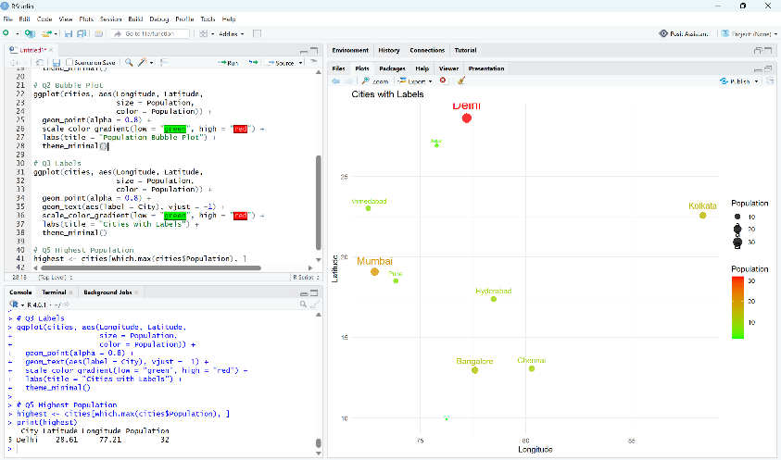
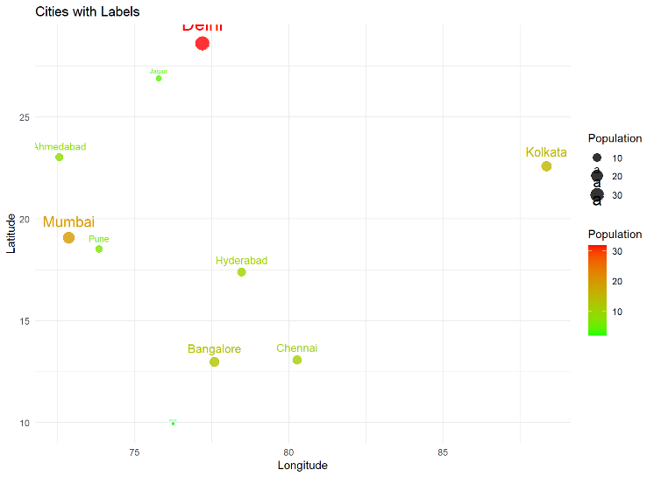
print(highest)

QUESTION 2
2. Network Visualization
Dataset

From | To
A | B
A | C
B | D
C | D
C | E
D | E
E | F
F | G
G | H
H | A
Questions
Q1. Create a network graph using the igraph package.
Q2. Display node labels and customize node colors.
Q3. Calculate the degree of each node.
Q4. Identify the node with the highest number of connections.
Q5. Plot the network using a circular layout.
CODE:
library(igraph)
library(RColorBrewer)
edges <- data.frame(
From=c("A","A","B","C","C","D","E","F","G","H"),
To=c("B","C","D","D","E","E","F","G","H","A")
)
g <- graph_from_data_frame(edges,directed=FALSE)
# Q1 Network Graph
plot(g,
vertex.size=35,
vertex.color="skyblue",
vertex.label.color="black",
edge.color="gray40",
main="Network Graph")
# Q2 Node Labels and Colors
V(g)$color <- brewer.pal(vcount(g),"Set3")
plot(g,
vertex.size=35,
vertex.color=V(g)$color,
vertex.label.cex=1.2,
edge.width=2)

# Q3 Degree
deg <- degree(g)
print(deg)
# Q4 Highest Connections
cat("Highest Connected Node:\n")
print(names(which.max(deg)))
# Q5 Circular Layout
plot(g,
layout=layout_in_circle(g),
vertex.color="gold",
vertex.size=35,
edge.color="blue",
main="Circular Network Layout")
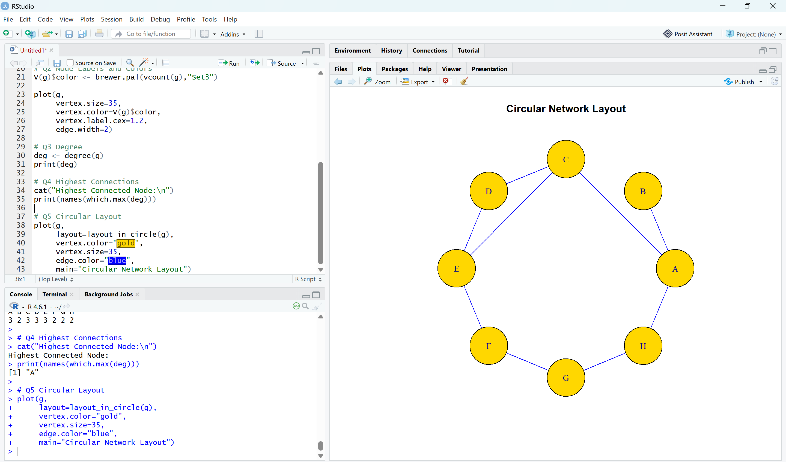
QUESTION 3
3. Temporal Data Representation
Dataset
Month | Sales (₹ Lakhs)
Jan | 120
Feb | 135
Mar | 150
Apr | 170
May | 190
Jun | 220
Jul | 210
Aug | 230
Sep | 250
Oct | 270
Nov | 290
Dec | 320
Questions
Q1. Create a line chart showing monthly sales.
Q2. Add custom month names using the axis() function.
Q3. Highlight the data points using pch = 19.
Q4. Display grid lines and proper axis labels.
Q5. Identify the month with the maximum sales from the graph.

sales <- c(120,135,150,170,190,220,210,230,250,270,290,320)
months <- month.abb
# Q1 Line Chart
plot(sales,
type="l",
lwd=3,
col="blue",
xaxt="n",
xlab="Month",
ylab="Sales (Lakhs)",
main="Monthly Sales")
axis(1,at=1:12,labels=months)
# Q2 Custom Month Names
axis(1,at=1:12,labels=months)
# Q3 Highlight Points
points(sales,
pch=19,
col="red",
cex=1.5)
# Q4 Grid Lines
grid()
# Q5 Maximum Sales
cat("Maximum Sales Month:",
months[which.max(sales)],"\n")
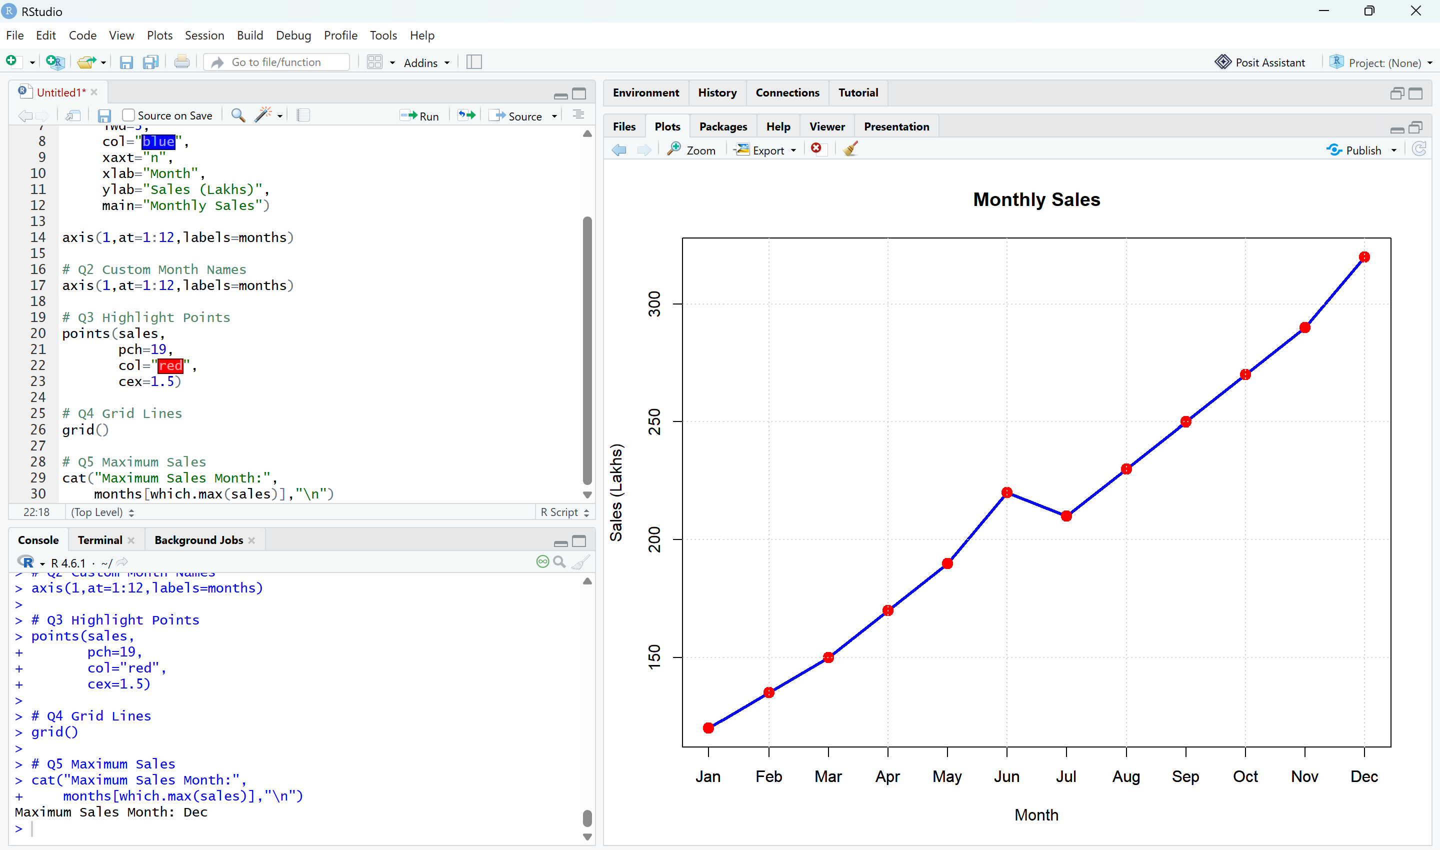

QUESTION 4
4. Multivariate Data Visualization
Dataset
Student | Marks | Attendance (%) | Study Hours | Projects
A | 60 | 75 | 2 | 1
B | 68 | 80 | 3 | 2
C | 74 | 84 | 4 | 2
D | 79 | 88 | 5 | 3
E | 82 | 90 | 5 | 3
F | 85 | 92 | 6 | 4
G | 88 | 94 | 6 | 4
H | 91 | 95 | 7 | 5
I | 94 | 97 | 8 | 5
J | 97 | 99 | 9 | 6
Questions
Q1. Create a bubble plot where:
- X-axis = Marks
- Y-axis = Attendance
- Bubble size = Study Hours
Q2. Produce a scatter plot matrix using the pairs() function.
Q3. Find the correlation among Marks, Attendance, and Study Hours.
Q4. Identify the student with the highest marks and largest bubble.
Q5. Create a heatmap showing the relationships among all numerical variables.
CODE:
library(corrplot)
students <- data.frame(
Student=c("A","B","C","D","E","F","G","H","I","J"),
Marks=c(60,68,74,79,82,85,88,91,94,97),
Attendance=c(75,80,84,88,90,92,94,95,97,99),
StudyHours=c(2,3,4,5,5,6,6,7,8,9),
Projects=c(1,2,2,3,3,4,4,5,5,6)
)
# Q1 Bubble Plot
symbols(students$Marks,
students$Attendance,
circles=students$StudyHours,
inches=0.25,
bg="purple",
fg="black",
xlab="Marks",
ylab="Attendance",
main="Student Performance Bubble Plot")
text(students$Marks,
students$Attendance,
labels=students$Student,
pos=3)
# Q2 Scatter Plot Matrix
pairs(students[,2:5],
col="blue",
pch=19)
# Q3 Correlation
correlation <- cor(students[,2:5])
print(correlation)
# Q4 Highest Marks Student
students[which.max(students$Marks),]
# Q5 Heatmap
corrplot(correlation,
method="color",
type="upper",
addCoef.col="black",
tl.col="black",
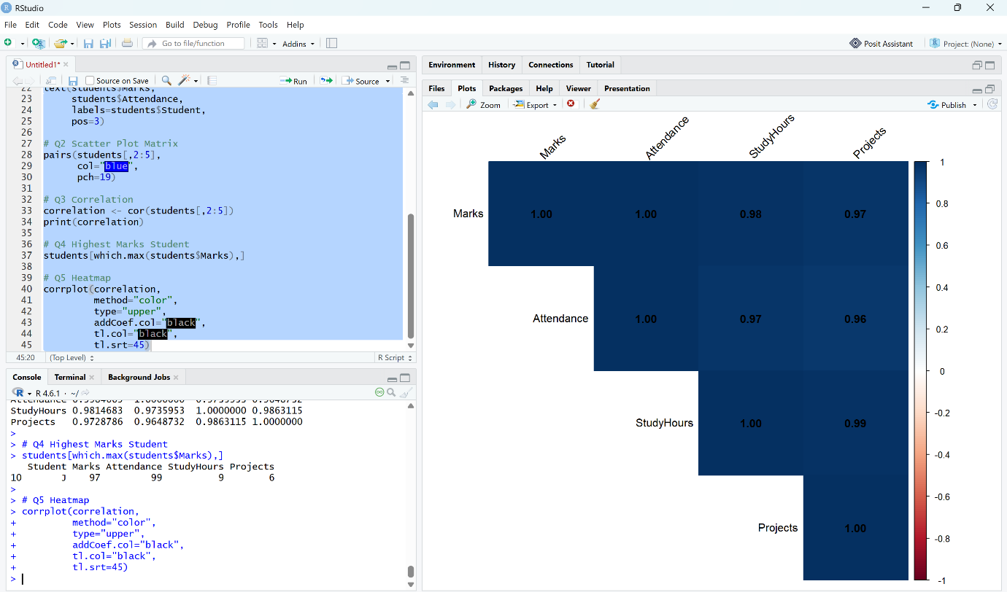
tl.srt=45)

QUESTION 5
5. Integrated Data Visualization Exercise
Dataset
Year | Sales | Profit | Customers | Branches
2016 | 150 | 20 | 1200 | 5
2017 | 170 | 25 | 1500 | 6
2018 | 200 | 32 | 1800 | 7
2019 | 240 | 40 | 2200 | 8
2020 | 260 | 42 | 2400 | 8
2021 | 300 | 55 | 2800 | 10
2022 | 340 | 65 | 3300 | 11
2023 | 390 | 72 | 3800 | 12
2024 | 430 | 82 | 4200 | 13
2025 | 480 | 95 | 4700 | 15
Questions
Q1. Create a temporal line chart showing yearly sales.
Q2. Generate a multivariate bubble plot with:
- X-axis = Sales
- Y-axis = Profit
- Bubble size = Customers
Q3. Compute the correlation matrix for Sales, Profit, Customers, and Branches.
Q4. Create a scatter plot matrix using the pairs() function.
Q5. Interpret the visualizations to determine whether an increase in branches is associated with higher sales and profits.
CODE:
library(corrplot)
data <- data.frame(
Year=2016:2025,
Sales=c(150,170,200,240,260,300,340,390,430,480),
Profit=c(20,25,32,40,42,55,65,72,82,95),
Customers=c(1200,1500,1800,2200,2400,2800,3300,3800,4200,4700),
Branches=c(5,6,7,8,8,10,11,12,13,15)
)
# Q1 Line Chart
plot(data$Year,
data$Sales,
type="o",
col="darkgreen",
lwd=3,
pch=19,
xlab="Year",
ylab="Sales",
main="Yearly Sales Trend")
grid()
# Q2 Bubble Plot
symbols(data$Sales,
data$Profit,
circles=data$Customers,
inches=0.3,
bg="orange",
fg="black",
xlab="Sales",
ylab="Profit",
main="Sales vs Profit vs Customers")
text(data$Sales,
data$Profit,
labels=data$Year,
pos=3)
# Q3 Correlation Matrix
cor_matrix <- cor(data[,2:5])
print(cor_matrix)
corrplot(cor_matrix,
method="circle",
type="upper",
addCoef.col="black",
tl.col="black")
# Q4 Scatter Plot Matrix
pairs(data[,2:5],
col="darkblue",
pch=19)
# Q5 Interpretation
cat("Interpretation:\n")
cat("Sales, Profit, Customers and Branches show a strong positive correlation.\n")
cat("As the number of branches increases, sales and profits also increase.\n")
cat("The scatter plots and correlation matrix indicate a positive business growth trend.\n")
